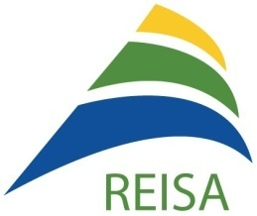

Annual Report
2018-2019

The East Island Network for English Language Services
Le Réseau de l'Est de l'Île pour les services en anglais

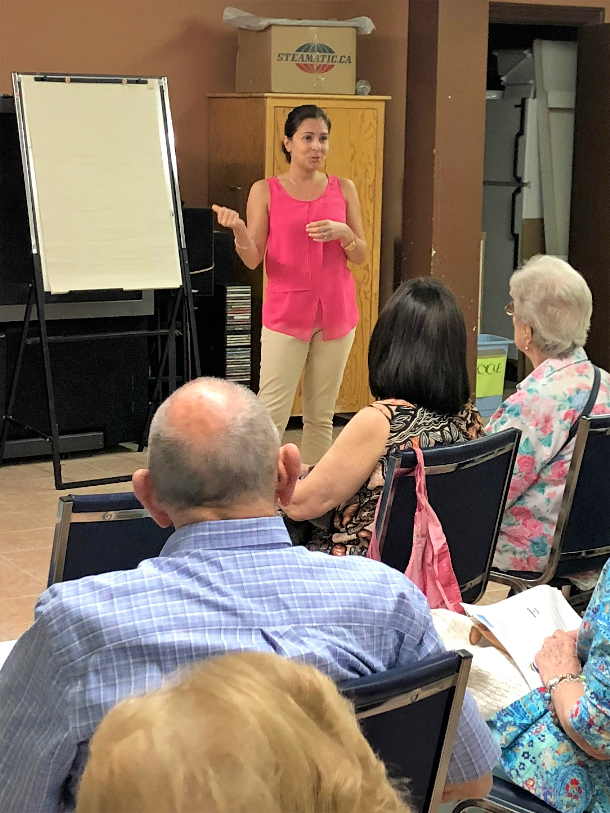
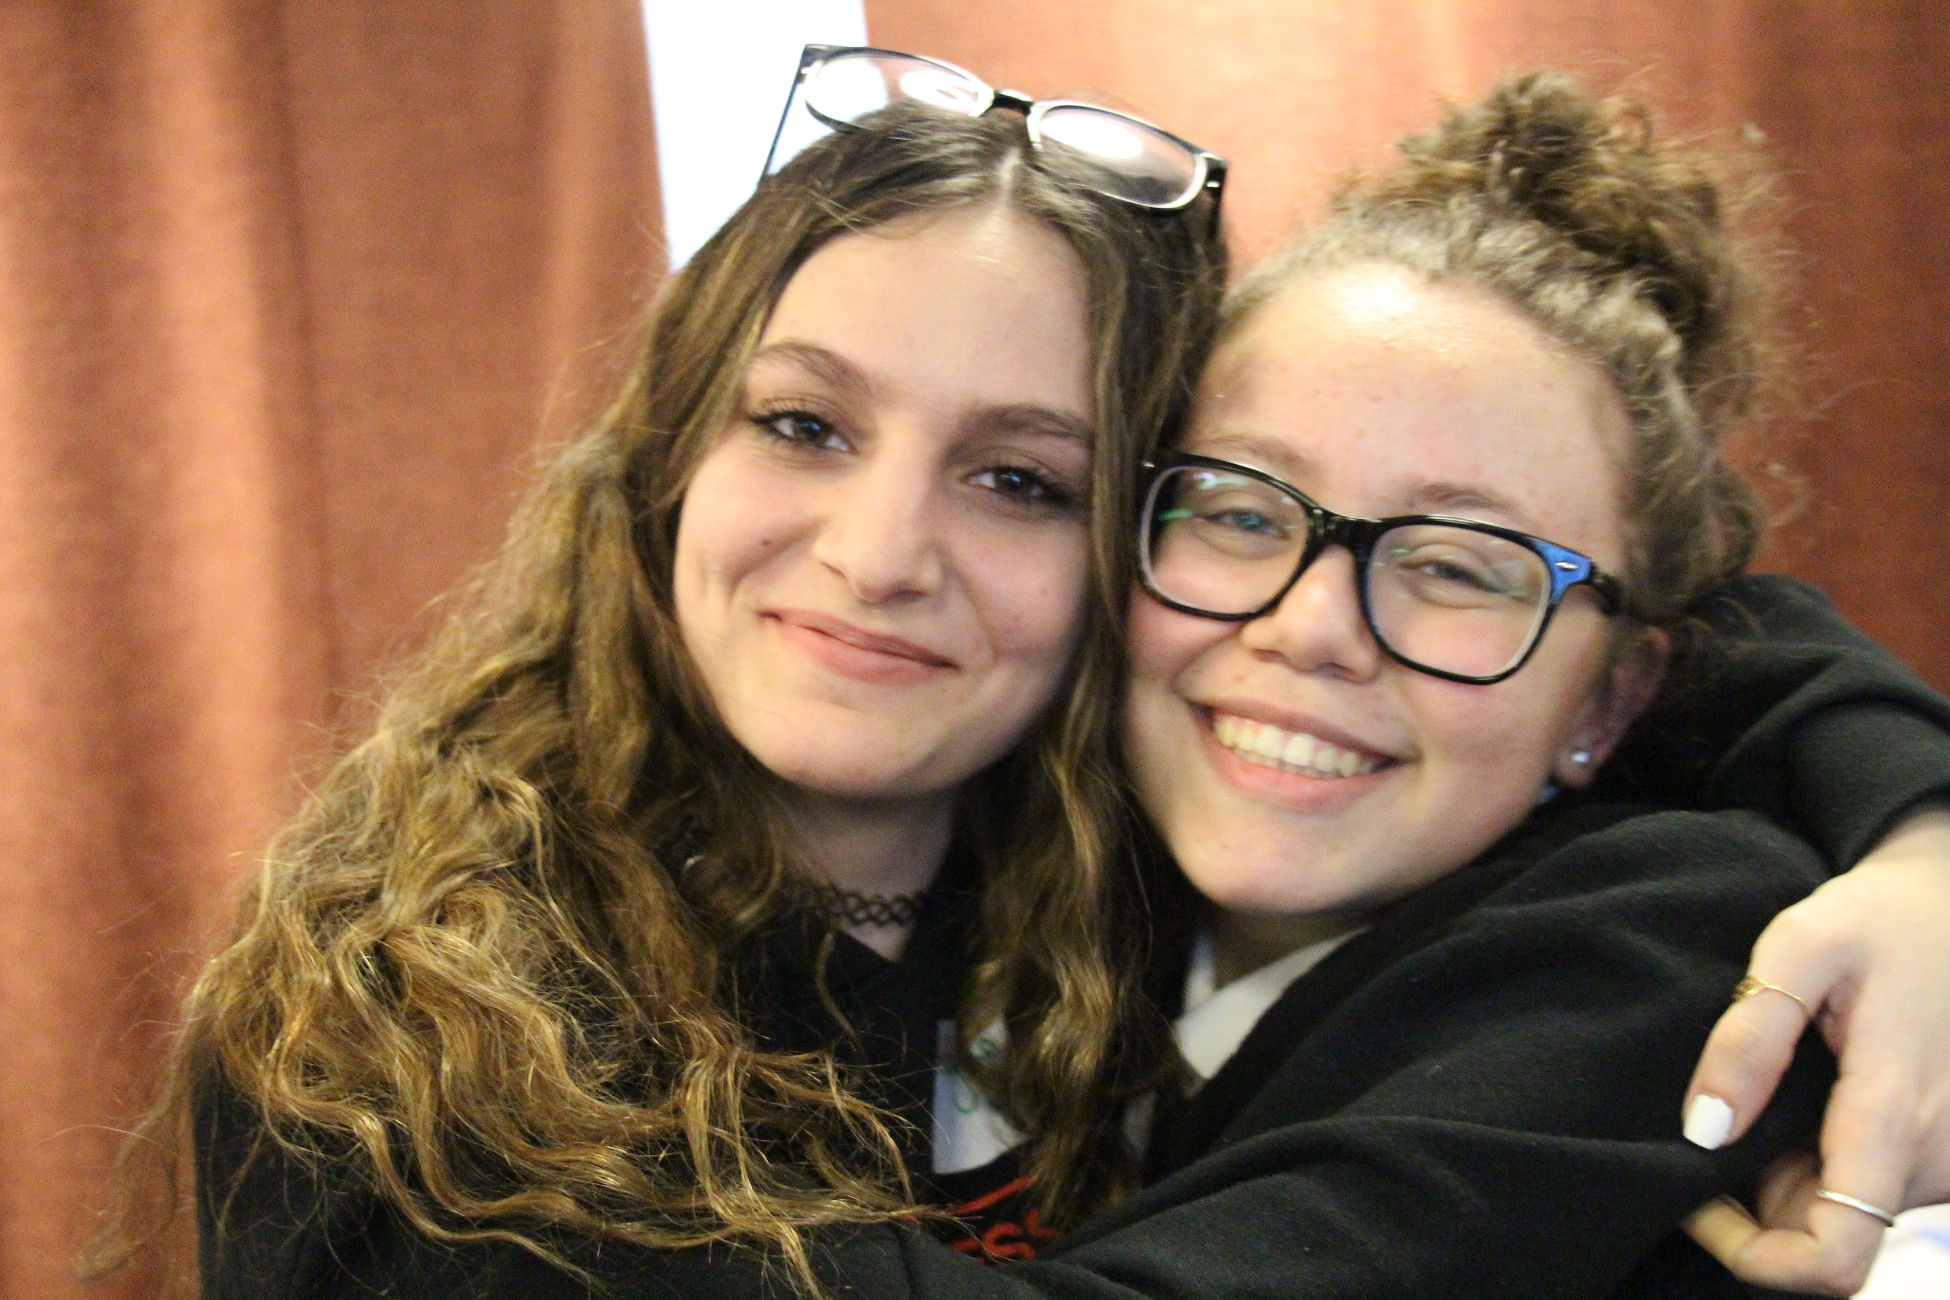
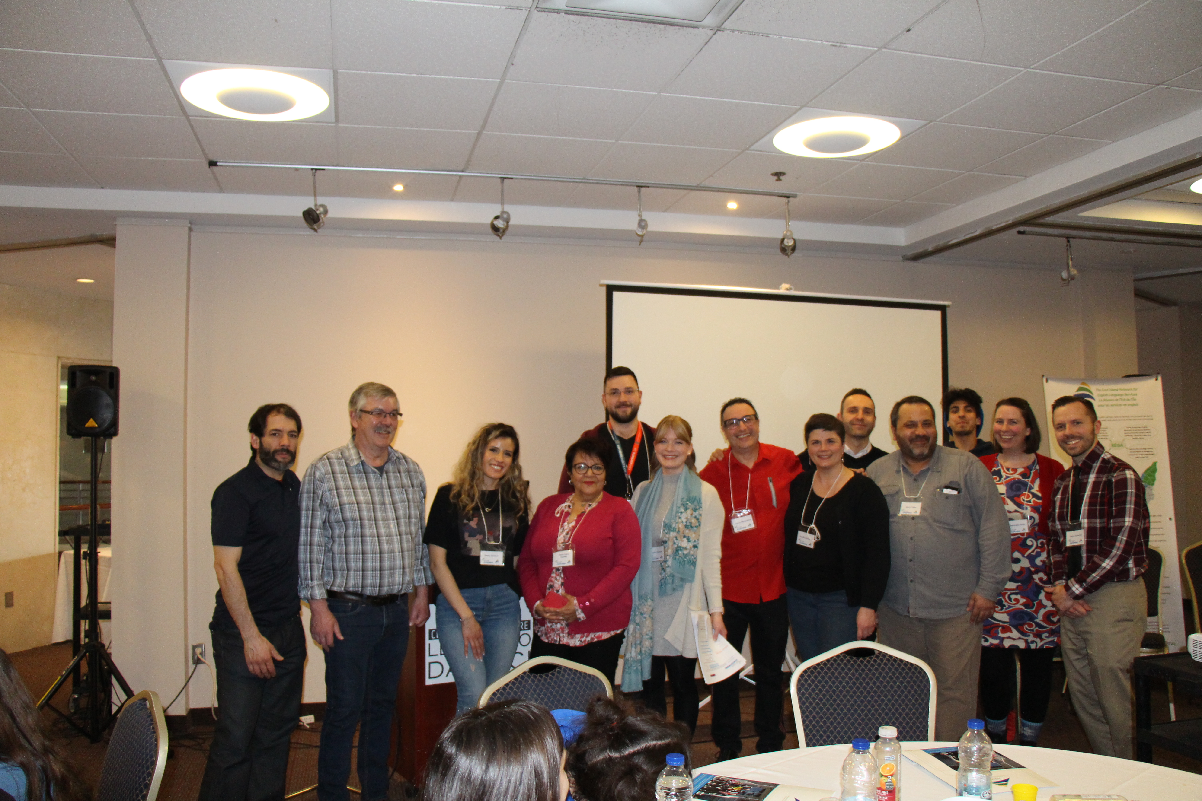

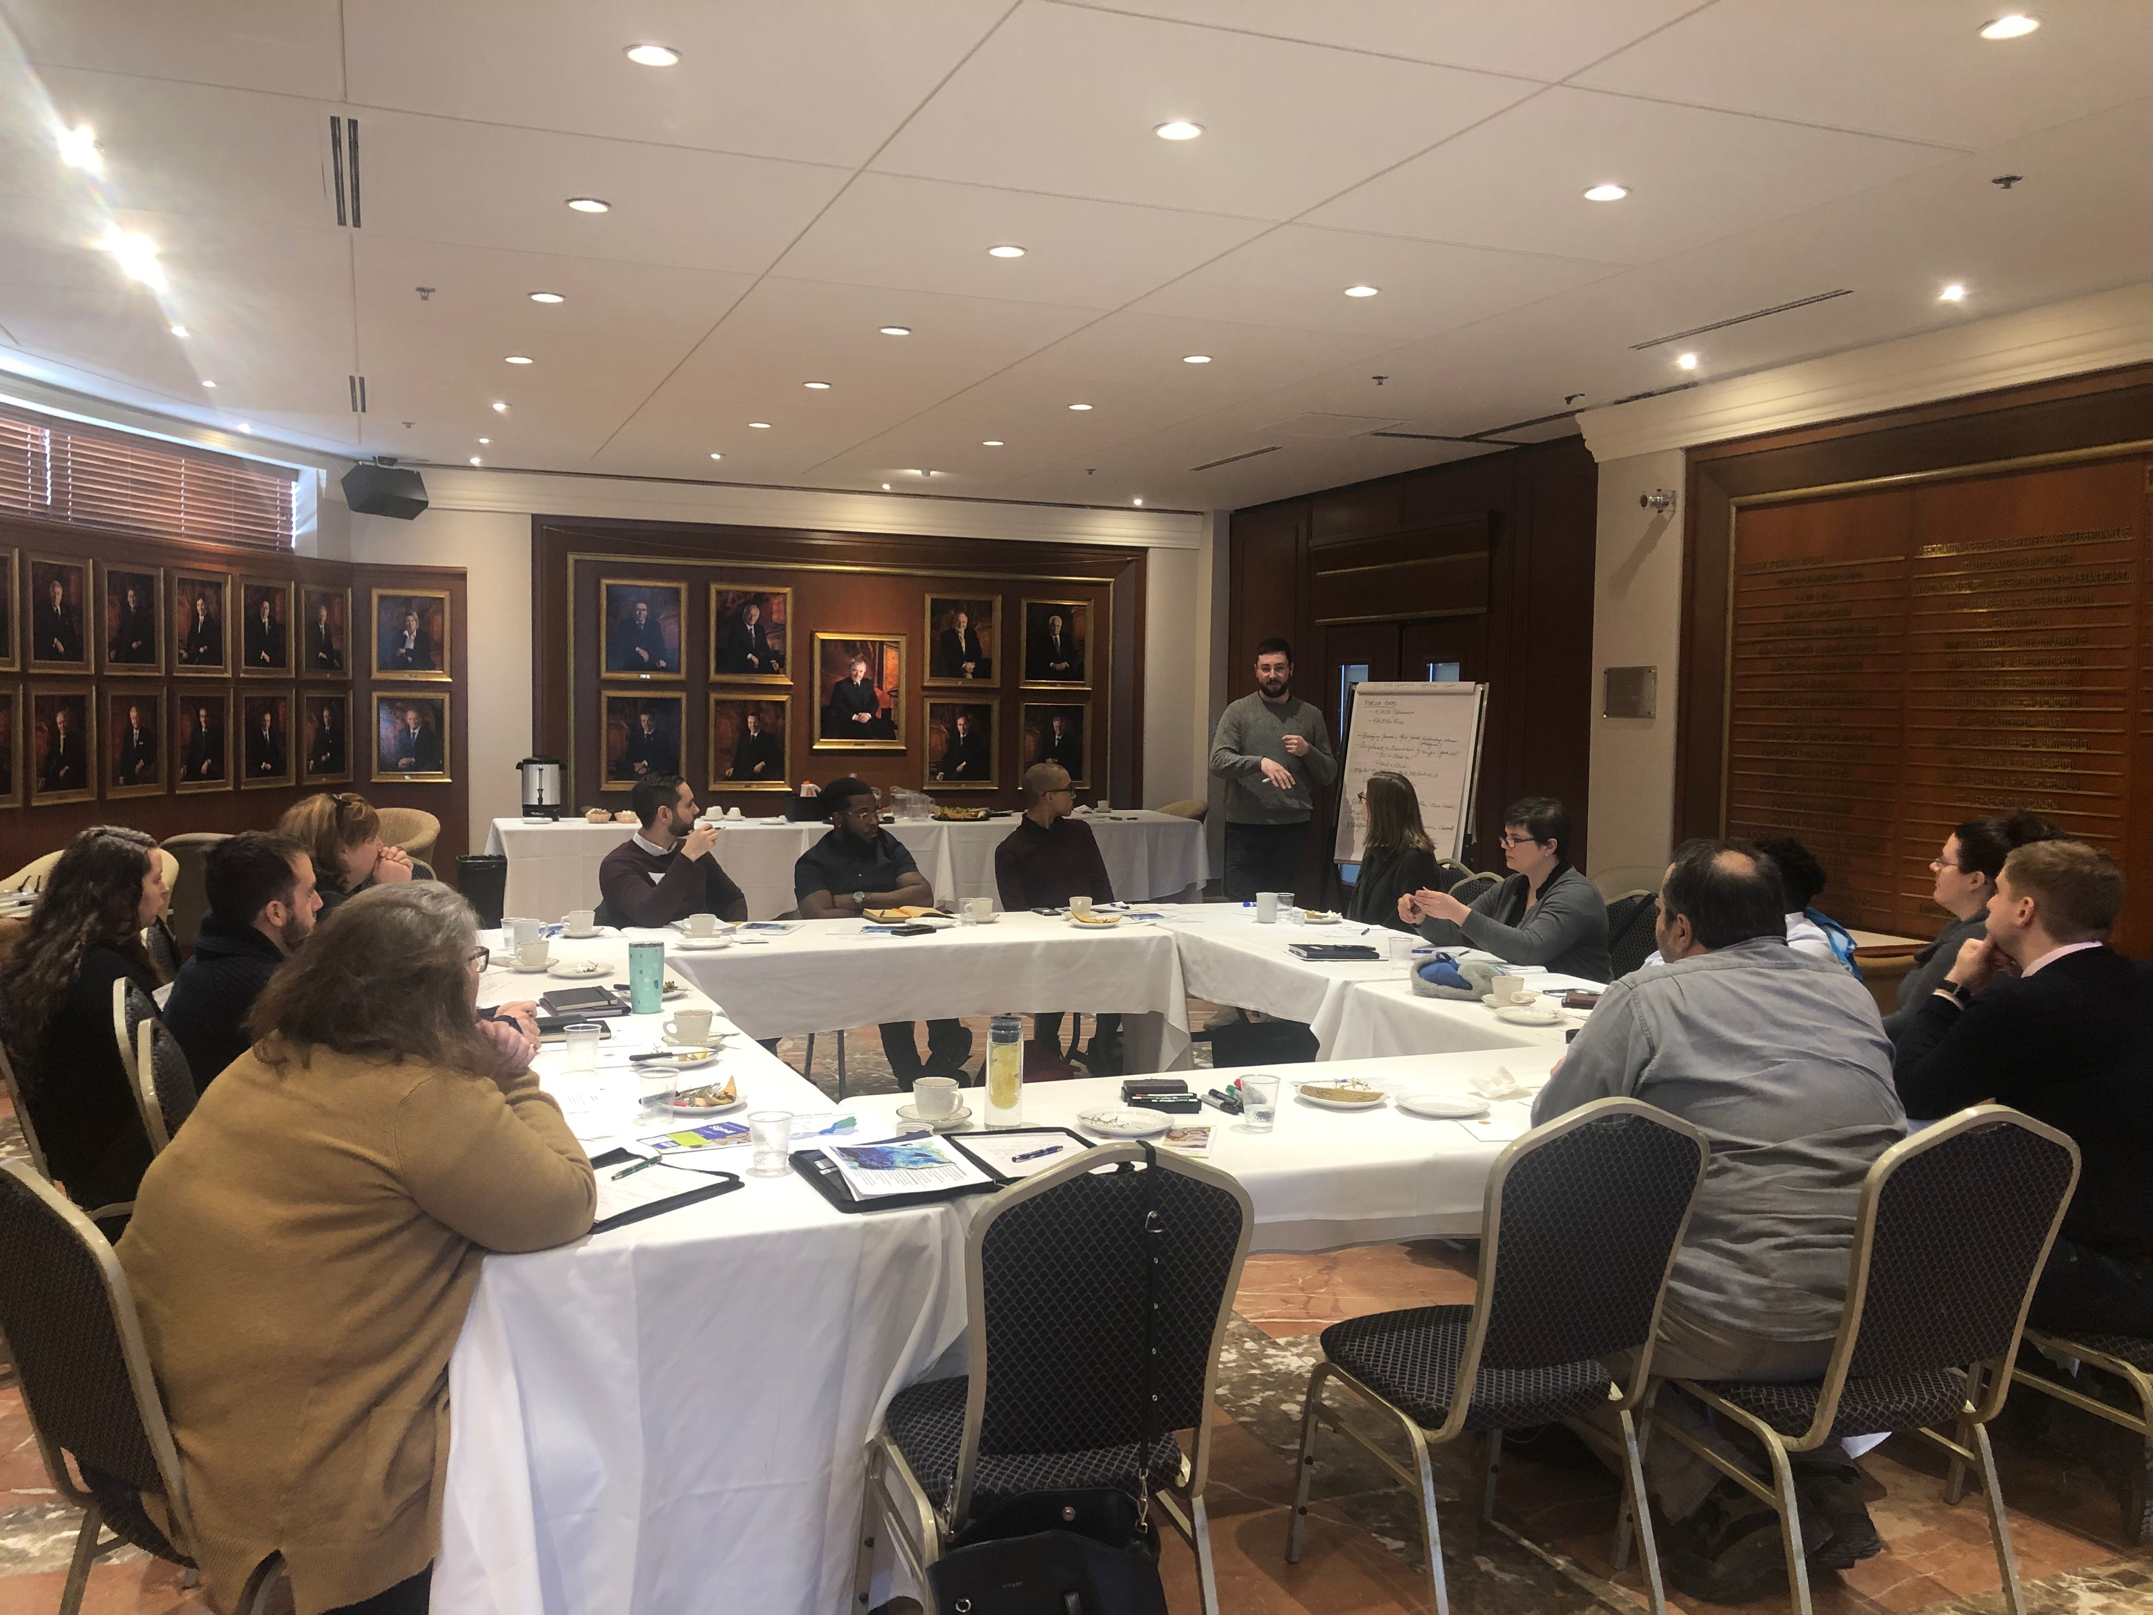
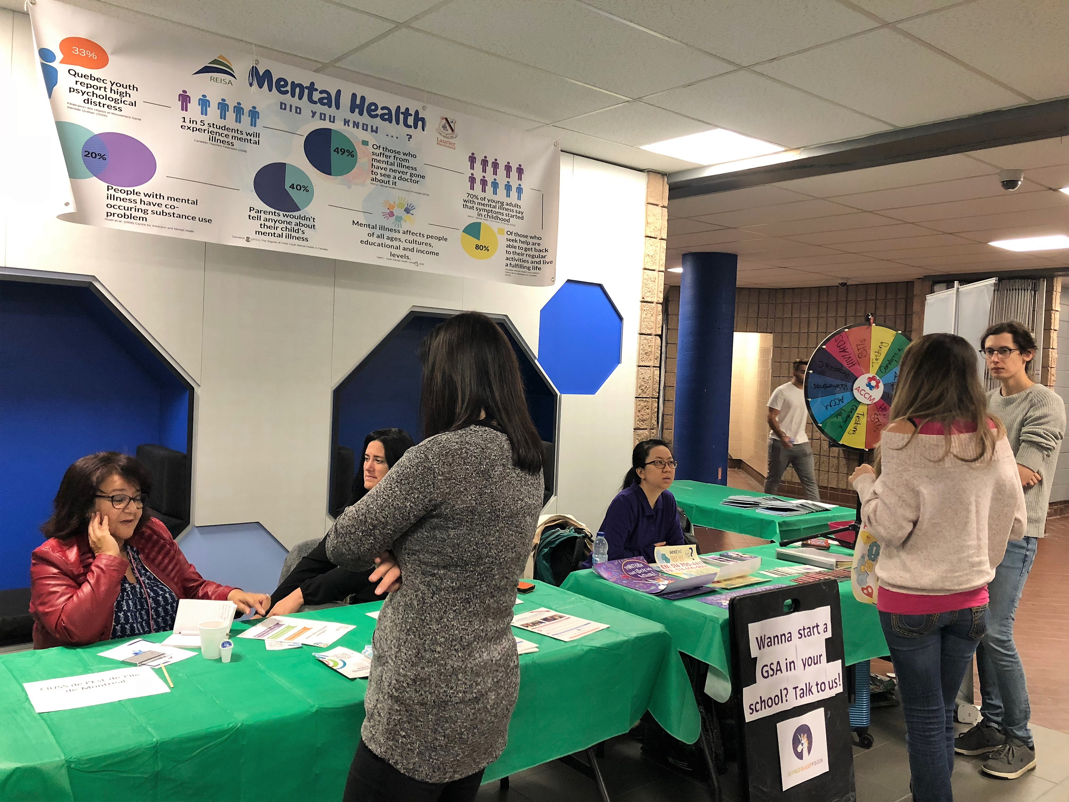
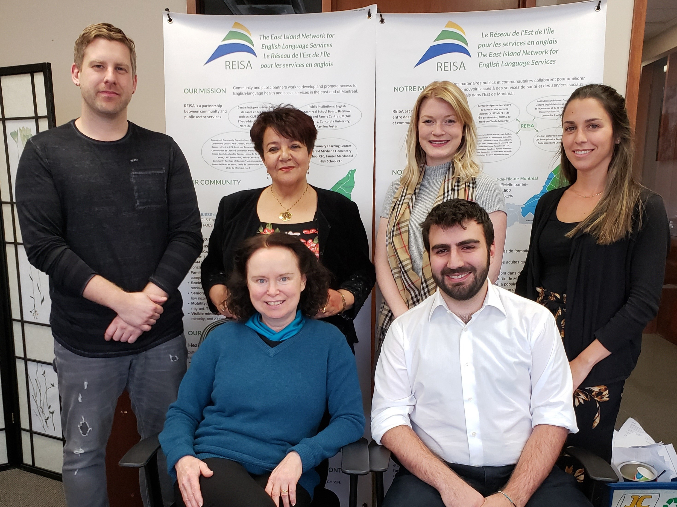
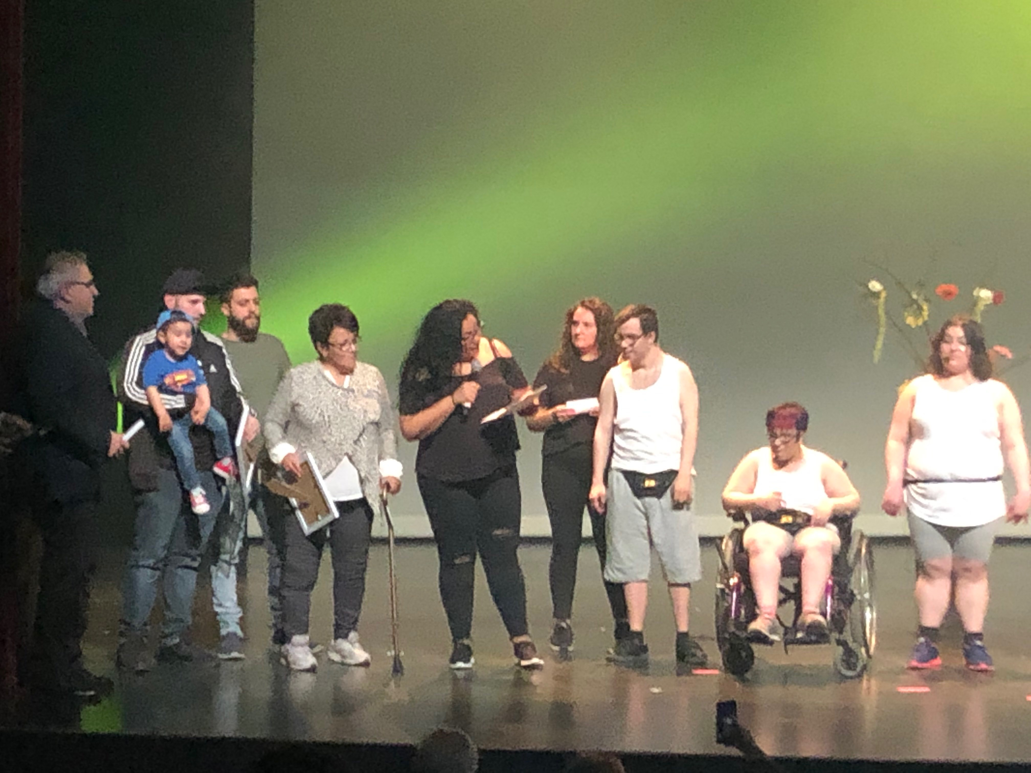
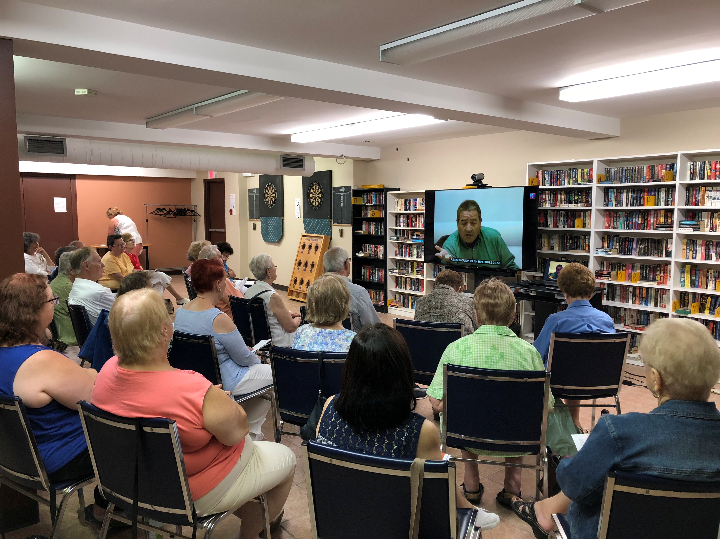

8370 boulevard Lacordaire, Suite 312, Saint-Léonard, QC H1R 3Y6

514-955-8370 #2217 info@reisa.ca www.reisa.ca REISA Montreal

Our Mission

The East Island Network for English Language Services-REISA, a community organization, works to increase access to health and social services in English for residents of Montreal’s east-end, through collaboration with public, private and community stakeholders.

English-speaking communities in the East and North end of the island represent a significant 17,8 % of the area’s population. However, it is common that the needs of these communities are overlooked. REISA seeks to promote access to health and social services in the English language in areas where minority groups are more comfortable receiving services in English than in French.

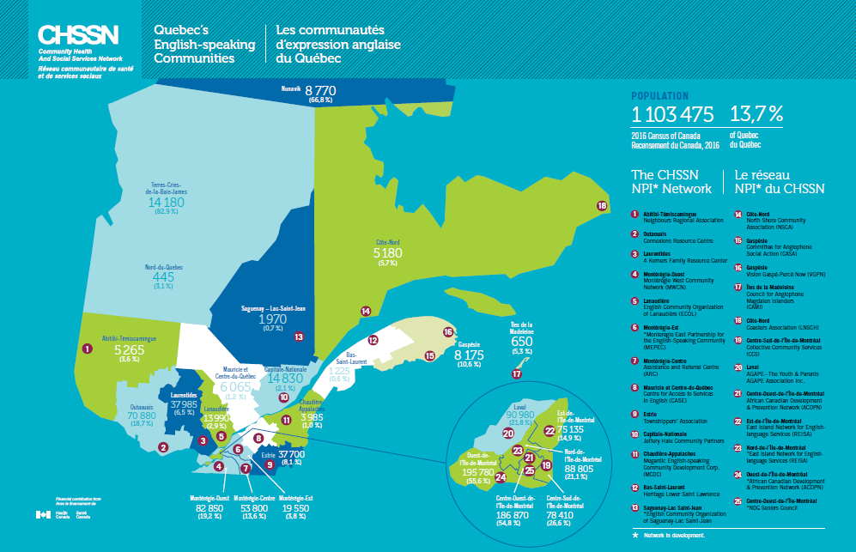

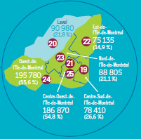

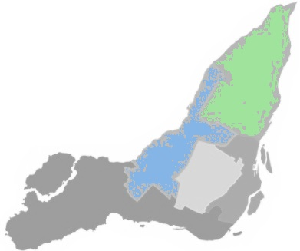

FOLS* English Total on the REISA territory:
163, 470
17,8%
CIUSSS du Nord-de-l’Île-de-Montréal
FOLS English:
74,575
14.9%

CIUSSS de l’Est-de-l’Île-de-Montréal
FOLS English:
88,895
21.4%

*First Official Language Spoken

Table of Contents

President's Message
Executive Director’s Message
pg 6
Board of Directors and Staff

pg 13
Minutes of the Annual General Meeting on June 14th, 2018

pg 8

NPI Regional Expansion

pg 15

Representation

pg 16
Network and Partnership Initiative

pg 14

Community Leadership and Coordination

pg 17
Knowledge Development

pg 18

Outreach

pg 19

Linguistic Adaptation of Health and Social Services

pg 22

Enhancing Regional Community Capacity- Youth Network

pg 25

McGill Training and Retention of Health Professionals

pg 27

President's Message

This year has seen a three-fold expansion at REISA: territory, team and mandate are all bigger than before. I would like to thank the members of the team under the guidance of a formidable Executive Director, for their hard work and dedication throughout the year.
The financial realities of REISA’s work, critical for the English-speaking community in the East and North Island, means that we must be careful to deploy our resources strategically. Every year, we set clear priorities and target those most likely to have a significant impact. To strengthen our impact for the benefit of our English-speaking community, we continue to explore our members’ evolving priorities to engage them and their volunteers in contributing to REISA initiatives.
Best of all, REISA’s targets are no longer limited to access to health and social services alone. We can finally swing into action for work on health determinants affecting our minority community. Economic status, at the top of the list, is at the heart of REISA Youth Network’s endeavors to increase the ease and confidence of young people as they prepare to compete in Montréal’s French job market.
A whopping 20% of young people of the East and North speak English, but Francophone employment strategies struggle to reach them: REISA’s Youth Network has gained surprising momentum in a very short time by helping with this. Exciting times ahead!

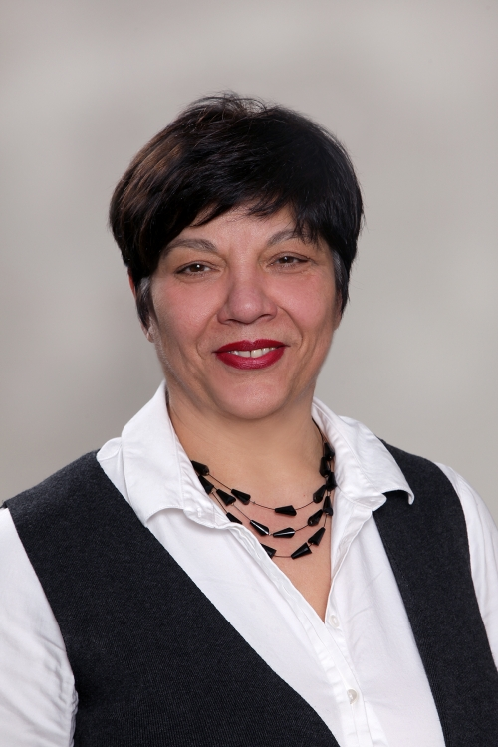
Josephine Primiani
President

Executive Director

The past year has been very productive for REISA with the regional expansion and the addition of ERCC- Enhancing Regional Community Capacity - Renforcement des capacités régionales des collectivités. Adapting to CIUSSS territories, the REISA Network has now been redefined as 2 networks: REISA North Network and REISA East Network, with a jump in the English-speaking population from 95,000 to 165,000.

We now serve the English-speaking communities (ESC) of our partnering CIUSSSs, both East and North. That’s 14 CLSC territories, up from the 10 we have worked with since 2006. The REISA team is meeting new potential partners in the superbly well-organized North, documenting the needs and hopes of groups serving the ESC and proposing contributions to new community objectives we are discovering.

Highlight of the year has been the creation of the very first REISA Youth Network and the opening of a satellite office near the border between East and North Island. Continuity in funding from the Adaptation of Health and Social Services Initiative allowed us to engage in an unexpected regional level of partnership for the linguistic adaptation of services with all five Montreal CIUSSSs and two other NPI groups.

REISA’s team now stands at six full-time and part-time employees who contribute an impressive variety of skills and experience to our Networks, as well as a yearly harvest of the best student interns from the Concordia School of Community and Public Affairs.

The following report outlines the programs and activities REISA has been involved with in Montreal’s East-end and North-End primarily, and within the Montreal region and throughout Quebec.

Fatiha Gatre Guemiri
Executive Director

Minutes of the Annual General Meeting on June 14th, 2018

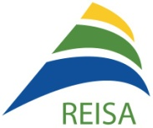
Minutes of the

Annual General Meeting of

The East Island Network for English Language Services-REISA

at the Leonardo Da Vinci Centre, salon des gouverneurs,

On Thursday, June 14, 2018,

At 9:00am

- Opening of the Annual General Meeting and reading of the Notice of Convocation
- Ella Amir opens the Meeting at 9:20am.

- Appointment of the Chairperson and the Secretary of the Meeting
- E. Amir appoints F. Guemiri as the Chairperson of the Meeting and M. Maiolo as the Secretary of the Meeting, seconded by J. Primiani and unanimously approved.

- Approval of the Minutes of the Annual General Meeting of June 28, 2017
- It is noted that there is a small correction in the minutes: point 5- the word ‘highlighting’.
- H. Nadler moves to approve the minutes of the AGM of June 28, 2017, seconded by J. Primiani.

- Presentation of the Annual Report for year ended March 31, 2018
  - The executive director thanks staff and board of directors for their hard work and contribution in 2017-2018;
Special thanks are extended to Janet Forsyth for her vision and volunteer work on the initiative for special needs and to Josie Primiani and Ghislaine Prata who sit on the boards of the CIUSSS and who have helped support REISA over the past year;
  - Presentation of the annual report highlighting the impact of various programs and projects on access to services.

Linguistic Adaptation/Liaison
    - Funding for linguistic adaptation of homecare services from the CIUSSS du Centre-Sud-de-l’Île-de-Montréal;
    - Liaison with Répondants pour les services en anglais from the CIUSSS du Centre-Sud-de-l’Île-de-Montréal, the CIUSSS de l’Est-de-l’Île-de-Montréal and the CIUSSS du Nord-de-l’Île-de-Montréal;
    - Liaison established between Almage Senior Community Centre and the satellite groups with homecare teams at 10 CLSCs;
    - New medical clinic at the Centre of Dreams and Hopes will offer the services of 1 doctor and one clinical nurse in early July (service agreements between REISA and the CIUSSS will be signed in June);
    - 14 walk in clinics (GMF) will allocate in June, 15-20% of time to special needs and senior clientele by appointment (1 clinic from CIUSSS du Nord and 13 clinics from CIUSSS de l’Est);
    - Collaboration with the Répondants of the 2 CIUSSS on the strategic plan for adaptation of services;
    - Importation of services to the East End: re-opening of a point of service at CLSC Saint-Léonard for addiction and mental health services. These services are now available at certain high schools in the east end 1-2 days per week.

McGill Training and Retention of Health Professionals
    - This year, REISA facilitated 18 internships in the East-end;
    - Interns are offered the opportunity to interact with diverse English speaking community groups (seniors, youth, families with special needs and addictions);
    - REISA has initiated the introduction of training on special needs to the McGill School of Nursing. The president of the Centre of Dreams and Hopes is in discussion with the McGill School of Nursing to bring clientele from the Centre to McGill to replace actors for specialized training courses for special needs clientele;
    - REISA is experiencing challenges in coordinating internships with bilingual students at health institutions in the East End.

Partnerships and Collaboration with EMSB and Community Partners
    - Service agreements have been signed with: Laurier Macdonald High School, John F. Kennedy High School, LIFT, YWCA, YMCA, Servizi (SCCIQ) and Almage Senior Community Centre;
    - REISA is in constant support to community partners for research of funding and grant applications;
    - REISA disseminates partner information.

Representation
    - Strategic participation on tables where REISA can contribute or sees an opportunity for the English-speaking community; learning of government funding, current initiatives, statistics;
    - REISA is represented at: CHSSN, McGill Dialogue, Ministry of Health and Social Services, Official Languages Commission, Secretariat for English Speaking Community, EMSB, QCGN, Community Learning Centres, Tables de quartiers (Saint-Léonard, Montreal Nord, Vivre Saint-Michel en Santé), Comité Jeunes Vulnérable, Comité pour contre l’abus et la maltraitance envers les aînés;
    - Laurier Macdonald high school's mental health strategy 2017-2020.

Health Promotion
Seniors
- New video conferencing unit installed at Almage Senior Community Centre;
- 5 Health Education sessions are presented to seniors via DVD. Each DVD is animated by health professionals and seniors receive the opportunity to ask questions following the DVD sessions;
- Over 100 seniors are reached through the Health Education program.

Youth-LIFT
- Program aimed to equip youth at risk with healthy living habits to achieve high levels of wellbeing;
- 53 youth from Laurier Macdonald and John F. Kennedy high schools participated in 18 workshops in the fall and winter sessions;
- 21 youth attended 1 week winter and summer camps;
- Students have provided positive feedback about the program (self-discovery, stress management, development of a healthy, well rounded life, achieving a sense of relief by sharing emotions and discussing valuable topics during workshops);
- J. Sbrollini, LIFT co-director, reports that 6 programs are planned for September 2018 and plans to expand to all EMSB are in the works. The co-directors of LIFT have been asked to give a workshop to all EMSB guidance staff;
- REISA applied for and received $2000.00 in funding from the YMCA comité jeunes vulnérables to help fund 1 session of LIFT.

Youth- YWCA
- 17 workshops offered by the YWCA on healthy relationships and sexting;
- 371 Youth participated from secondary 3-5;
- 2 high schools participated.

Outreach
- In February 2018, REISA launched a new outreach initiative to identify English Speaking recent immigrants, refugees and asylum seekers who settled in the east end of Montreal;
- The executive director introduces the consultant who has been working on the initiative and her findings;
- More than 30 federal, provincial, municipal and community organizations have been contacted;
- A large number of new comers have left Québec for other provinces, some have settled in the West Island;
- Haitian ESP children integrated in French schools and their families face new language related challenges;
- Montreal North area has been covered, REISA will now reach out to Saint-Michel.

Knowledge Development
    - General resource guide and senior's guide updated yearly; special needs guide in development;
    - Community Network Forum Report, Special Needs Forum Report and REISA’s Annual Report are disseminated;
    - CHSSN Baseline Data Reports and community profiles shared with the health institutions;
    - REISA newsletters, health promotion events, programs and information provided by Health Canada are shared with REISA network;
    - REISA team attends various training, webinars, and retreats;
    - 2 new features are added to www.reisa.ca: ‘Meet the REISA team’ and ‘REISA Job and Volunteer Bank’.

Forums
- REISA plans and organizes the annual Community Network Forum and a Forum for Special Needs;
- Forum reports are produced and shared with the network partners and uploaded to the REISA website.

Planning 2018-2019
- Executive Director announces that REISA’s priorities for 2018-2020 will focus on mental health and youth;
- REISA is planning a mental health fair at Laurier Macdonald in October 2018;
- REISA will be planning a mental health forum with community and health institutions- March 2019;
- REISA would like to plan an expansion for youth services with partner Don Bosco Youth Leadership Centre.

- Adoption of Bylaws reviewed in July 2017
  - H. Nadler motions to adopt bylaws, seconded by E. Amir.

- Acceptance of the Financial Statements for the financial year ended March 31, 2016
  - H. Nadler, Board Secretary and Treasurer presents the statements; this year, an un-audited notice to reader is presented; REISA's financial are closely monitored by the CHSSN that requests 2 Cash flow and record of expenditure per year (a Request by Health Canada);
  - Observations by H. Nadler: impressive amount of work and results from the REISA team; thanks the team and consultants led by F. Guemiri;
  - Revenues from 3 sources: CHSSN, McGill and Agence de santé et de services sociaux under the CIUSSS –Centre-Sud-de-Montreal (the last 2 years);
  - H. Nadler moves to accept the Financial Statements, seconded by J. Primiani and D. D’Abate and unanimously approved.

- Appointment of the Auditor for the current fiscal year
  - H. Nadler moves to reinstate Chapman and Chapman as REISA's financial auditor for the 2018-2019 fiscal year, seconded by J. Primiani.

- Election of Board of Directors
  - F. Guemiri reads aloud the names of the current Board Members;
  - F. Guemiri moves that the current Board of Directors is reinstated with Rosanna Padula representing Almage, Roberto Leclerc representing Don Bosco and Gerry Tullio and Lucy Macias as an individual with expertise;
  - L. Macias introduces herself to the board;
  - Both motions are unanimously approved; Board positions will be determined at a Board meeting immediately following the AGM.

- Question and Answer period
  - H. Nadler asks that Batshaw Youth and Family Services be removed from his name, he no longer represents the organization;
  - C. Neal from the QCGN announces the upcoming QCGN AGM and highlights that could be useful for the community; Speed dating segment with provincial and federal funders, Agenda for English speaking debate during next election campaign.

- Closing of the Annual General Meeting
  - F. Guemiri moves to close the Annual General Meeting, unanimously approved.
  - The Meeting ends at 10:42am.

Attendance
Board members present
Amir, Ella | Ami-Quebec
D’Abate, Dominic | Consensus Mediation
Leclerc, Roberto | Don Bosco Youth leadership Centre
Padula, Rosanna | Almage Senior Community Centre
Primiani, Josie | Centre of Dreams and Hopes
Tullio, Gerry | Individual bringing expertise
Maiolo, Maria | SCCIQ
Marsillo, Joe | Toxico-Stop
Nadler, Howard | Individual bringing expertise
Seales, Sean | BCRC
Partners and guests present |  | Partners excused
Forsyth, Janet |  | Doonan, Diane
Gallant, Elvira | CIUSSS du Nord-de-l’Île-de-Montréal | Gleason, Dorothy
Macias, Lucy | Almage | Williams, Dorothy
Morneau, Emilie | Concertation Saint-Léonard
Neal, Christopher | QCGN
Salvatore, Matilde | ICCSQ
Sbrollini, Jonathan | Camp LIFT
Szpotowicz, Monika | CIUSSS de l’Est-de-l’Île-de-Montréal
Urquhart, Sandy | Almage
Variantzas, Bobbie | LEARN
Staff present
Guemiri, Fatiha
Thomas, Caitlin
Di Lollo, Rosalie
Board of Directors and Staff

Board of Directors Organisation
Amir, Ella AMI-Québec
D'Abate, Dominic Consensus Mediation
Della Cioppa, Victoria English Montreal School Board
Macias, Lucy Individual bringing expertise
Maiolo, Maria- Vice President Italian-Canadian Community Services of Québec
Marsillo, Joe Toxico-Stop
Nadler, Howard Individual bringing expertise
Seales, Sean Black Community Resource Centre
Primiani, Josephine- President East Foundation, Centre for Dreams and Hopes
Tullio, Gerry- Secretary and Treasurer Individual bringing expertise
Vecera, Theo Don Bosco Youth Leadership Centre

Staff Title
Gatre Guemiri, Fatiha Executive Director
Thomas, Caitlin Coordinator
Black, Jordan Coordinator
Forsyth, Janet Consultant - Linguistic Adaptation
Nancy Ibrahim Researcher

Networking and Partnership Development

The NPI is a program designed to support Quebec’s minority English-speaking communities in improving and maintaining access to the full range of Health and Social Services. The program supports the capacity of Quebec’s English-speaking communities to ensure their vitality through cooperation and partnership with the health and social services system. Funding for this program is provided by Health Canada and the program is managed by CHSSN.
Board and Partner Meetings
- 6 Board/partner meetings and the Annual General meeting held. Network updates presented on program development and progress.
- Gerry Tullio and Lucy Macias are elected to the Board of Directors as individuals with expertise.
- REISA Partner Ella Amir named to the provincial Committee for the Provision of Health and Social services in the English Language.

NPI Best Practice Sharing

- Sharing with NPI network: disseminating health information; workshops, and other learning opportunities.
- Networking and training at the CHSSN retreats in November 2018 and March 2019 in Quebec and Ottawa.
- Meeting in Knowlton with NPI groups from Greater Montreal and the Townships.

CIUSSS de l'Est-de-
l'Île-de-Montréal
CIUSSS du Nord-de-l'Île-de-Montréal

- CIUSSS de l'Est: Meeting with newly appointed répondant for access to English services, presenting REISA's role and mission and seeking support in the dissemination of ongoing Health promotion and Adaptation programs to the various heads of departments within the CIUSSS de l'Est.
- CIUSSS du Nord: 2 meetings with répondant for access to English services, seeking support on the strategic plan for adaptation of services.
- CIUSSS du Nord: Ongoing collaboration and organization of medical clinic at Centre of Dreams and Hopes offering the services of 1 doctor and one clinical nurse. An agreement is signed between the CIUSSS, REISA and CDH.

NPI Regional Expansion

REISA expansion to CIUSSS du Nord territory
- REISA hires a part-time researcher to survey the communities on the new territory.
- Community resources in Ville Saint-Laurent and Bordeaux-Cartierville are documented.
- Community groups are contacted to discuss capacity for serving the English-speaking community.
- Demographic profile of new territory in production.
- REISA has established a new satellite office in Ahuntsic – Bordeaux Cartierville. The location will be more accessible to potential partners on the new REISA territory.
- Partner meetings are planned for 2019-2020.

- REISA has established a new satellite office in Ahuntsic – Bordeaux Cartierville. The location will be more accessible to potential partners on the new REISA territory and will allow us to host meetings with CIUSSS du Nord health professionals and community groups (youth and other).

Establishment of satellite office in new territory

Representation
- Participation in the TQMN Annual General Meeting and 2 regular meetings.
- Participation in Aire Ouverte Montréal-Nord.
- Participation in 2 regular meetings Comité immigration et Vivre Ensemble (Montréal-Nord).
- Participation in la Concertation Saint-Léonard networking meetings and AGM.
- Presentation of REISA's role and mandate and health promotion projects.
- Participation in meetings for Services Léonardois pour les demandeurs d’asile.
Table de
Quartier Montréal-Nord

Comité immigration et vivre ensemble (Montréal-Nord)

Concertation Saint-Léonard

Community Learning Centres
& community partners

- Representation and presentation of the ESP stats and needs at the mental health planning committee at Laurier Macdonald.
- Regular planning meetings with Laurier Macdonald CLC coordinator for in-school programs.
- Representation at Laurier Macdonald Mental Health Fair.
- Participation in CHSSN/QUESCREN research workshop - new resources on English-speaking Quebec.
- Representation at McGill Centre for Studies in Aging Symposium and Open House.
- Representation at 2018 HCALM International conference.
- Representation at LaSalle D&D AGM.
- Representation at AQPS press release.
- Presentation of services to Concordia University Health Promotion class.
- Representation at AMI-Quebec Young Carers Symposium.
- Representation at EMSB Career Fair.

Community Leadership and Coordination
Contacts with local Government Representatives

- Representation and presentation of the ESP stats and needs in a meeting with the office of Melanie Joly minister of Official Languages, Tourism and francophonie.
- Press conference & program announcement by the Secretariat Responsible for Relations with English-Speaking Quebecers.

Community Network Forum

- Communications and meetings between Montreal regional NPI groups for the organization of one community forum.

Knowledge Development
Knowledge disseminati-on to public institutions
- Dissemination of health promotion events, programs and information provided by Health Canada.
- Dissemination of CHSSN baseline data reports and community profiles via email to community groups. Community profiles and statistical data shared with Health institutions through the Adaptation project.
- 30 Facebook posts; 24 website posts.
- REISA is featured on 2 editions of Red Feather Forum and CHSSN Netlink.

- Regular conference calls with the CHSSN and networks.
- Training at biannual CHSSN retreats: Themes included leadership, Turf and Trust, Reporting, Enhancing Regional Community Capacity program coordination.
- Videoconference and teleconference workshops: Educaloi programming; AQPS resources training; ERCC orientation training; CHSSN intergenerational programming; Canadian Mental Health Association resource sharing.
Training workshops and conference calls

Resource Guides

- Updating and disseminating REISA's general resource guide, special needs resource guide, and senior’s resource guide.

REISA website upgrading

- Job and volunteer bank and meet the team pages added to the REISA website. Community partners post 8 jobs to REISA’s database.

Website
Number of Visitors: 4,384
Most viewed pages:
Looking for a family doctor
Contact us
Job postings
Highest amount of new Visits: October

Facebook
Total page followers: 119
Total page likes: 112
Total number of friends: 150
29 posts in 2018-2019

Outreach
Special needs

- Ongoing collaboration with the 2 CIUSSS and REISA for expansion of services to special needs clientele.
- Meetings with the PDG of CIUSSS du Nord-de-l’Île-de-Montréal and the director of special needs services at the CIUSSS de l’Est-de-l’Île-de-Montréal for the establishment of a new medical clinic at the Centre of Dreams and Hopes.
- New medical clinic at the Centre of Dreams and Hopes to offer the services of 1 doctor and clinical nurse.
- Service agreement between CIUSSS du Nord and REISA is signed in July.
- REISA supports the Centre of Dreams and Hopes in 2 grant applications. CDH receives funding from Canadian Heritage for the Community Cultural Action Fund for a play produced and performed by 15 youth and young adults with special needs.

Seniors

- Presentation of 9 CHEP DVD sessions to members of the Almage Senior Centre and satellite centres.
- 2 visits to Almage Montreal-North and Rosemont satellite groups to document member’s satisfaction of health services on the territory.
- Meeting with newly appointed Executive Director of Almage Senior Community Centre for collaboration planning.
- Participation in the McGill Centre for Studies in Aging annual health symposium. REISA had a kiosk and informed the community about support to the English-speaking community in the east end of Montreal.
- Dissemination of information on events to partners serving the senior community.
- Support to Almage and SCCIQ for funding applications and project development.

Outreach cont.
Youth at risk
and
Mental Health

- LIFT program piloted by REISA in 2017 in 2 secondary schools is disseminated by the school board to other schools in the east end and across Montreal.
- LIFT program has been adopted into the curriculum of 3 east end high schools (Laurier Macdonald, John F Kennedy, and Rosemount).
- REISA pilots LIFT at Lester B Pearson as of January 2019.
- Planning and funding of Youth Mental Health Fair at Laurier Macdonald high school on October 2nd and 3rd 2018. 5 planning meetings from April 2018 to September 2018. REISA produces a statistical study and acts as a liaison between the two CIUSSS and the school. Both CIUSSS de l’Est and CIUSSS du Nord attend the fair and present trajectory of services to students, school staff, and parents. 6 high schools in the east end attend the fair. Parents from the 6 schools are invited to attend an evening information session and a representative from the CIUSSS de l’Est volunteers to attend the session for parents to present services.
- Planning and funding of Headstrong mental health summit for youth on March 21, 2019. 6 meetings and teleconferences are organized by REISA to plan the east end Headstrong summit. 5 schools attend the summit with a total of 90 participants (students, school staff, and community members).
- Opening of a new office for REISA Youth Network (see ERCC for more details).

Intergenerational programs
- Funding of intergenerational programs at John F Kennedy high school. Students and local community will collaborate together to build and plant a community garden on JFK grounds. A Bocce Ball court will be built; seniors and students will be invited to form teams and participate in joint tournaments.

Outreach cont.
Refugees, recent immigrants, and asylum seekers

Educaloi

Addiction services in the east end of Montreal

- More than 30 federal, provincial, municipal and community organizations were contacted by REISA.
- Meeting with agent de développement- demandeurs d’asile Saint Léonard.
- REISA encounters difficulty in identifying English-speaking immigrants and refugees in the east end. Efforts will be made to survey the newly expanded REISA territory.
- 1 legal information session is planned and carried out at Lester B Pearson high school, 32 students participate. Topics presented: What is legal and what is not online; Rules in the Workplace.
- 2 legal information sessions are planned and carried out at John F. Kennedy high school (2 consecutive classes), 80 students participate. Topics presented: What is legal and what is not online; Rules in the Workplace.
- 3 legal information sessions for seniors are planned with Almage Senior Community Centre and their 2 satellite centers. Topics presented: Fraud prevention and protection mandates.
- REISA develops a partnership with the McGill Legal Information Clinic.
- REISA organizes a meeting with all three Montreal NPI groups (REISA, CCS, ACDPN) and CAAP Montreal to meet with the entire CAAP team and discuss future collaborations.
- REISA agrees to help CAAP Montreal translate documents to English along with a PowerPoint presentation for community groups. Once this presentation has been translated, CAAP Montreal has agreed to present to REISA partner organizations.
- REISA informs partners of Educaloi resources and services.
- REISA sensitizes community members to the importance of making complaints with the health and social services system.
- Follow up and monitoring of Foster addiction rehabilitation center on satellite services offered in the east end of Montreal.
- Meeting with Chabad Lifeline addiction services. REISA will support Chabad Lifeline in efforts to reach out to the east end population.
Linguistic Adaptation of Health and Social Services

Linguistic
Adaptation

- Meeting with CIUSSS du Centre-Sud-de-l’Île-de-Montréal, CHSSN and Montreal NPI Networks to discuss Montreal initiatives.
- Adaptation meeting with Répondants of the Montreal CIUSSS’, NPI networks to present the adaptation projects.
- Meetings with newly appointed Répondants of the 2 CIUSSS to present REISA Network, mandate and programs, and identified areas of action for access to English services.
- Collaboration with the CIUSSS on the proposed action plan for Adaptation 2018-2023.

Community Focus Groups

- Regional partnership between 5 CIUSSS and 3 NPIs to collect qualitative data on negative experiences with institutions of the Montreal HSSN due to language issues since January 2016.
- Phone meeting with Adjointe Intérimaire à la Directrice des services multidisciplinaires to discuss community focus groups.
- Meeting at CIUSSS du Centre-Sud-de-l’Île-de-Montréal with Adjointe Intérimaire à la Directrice des services multidisciplinaires and Montreal NPI groups for the planning of community focus groups.
- 4 community focus groups (seniors, special needs, addictions/homeless, and young mothers) held to survey access to services for the ESP.
- Analysis and recommendation report is compiled and submitted to CIUSSS du Centre-Sud-de-l’Île-de-Montréal.

2019 Focus Group Project with beneficiaries of the Health and Social Service Network (HSSN)

This regional partnership between 5 CIUSSS and 3 NPIs collected qualitative data on negative experiences with institutions of the Montreal HSSN due to language issues since January 2016. Each NPI met four groups of English-speaking, vulnerable beneficiaries. Exchanges were recorded in m4a files and by transcript and then analyzed. REISA met 5 homeless men with addiction problems, 8 parents of children with intellectual disabilities or autism spectrum disorders, 5 senior women, and 6 mothers of infants and preschoolers; all but one were residents of the CIUSSS East or CIUSSS North. Here are some problems that came to light.
- English speaking homeless made to feel that it is in their interest to move to areas where services are bilingual? That they do not really belong in Francophone neighborhoods? That Francophone institution have less responsibility towards this group of residents, who should be seeking services elsewhere? Participants described being made to feel unwelcome, discriminatory attitudes, hostility, unfair judgment, linguistic profiling, and what seemed to them deliberate obstacles in accessing services. Can the regional model of indicated and designated institutions build a future in which each CLSC, hospital and CHSLD has acquired a diverse staff that resembles the population it serves?

- Seniors reported problems in obtaining medical explanations in English: staff in some institutions may fear intimidation if they use English, causing professional faults in obtaining informed consent.

- In a region where English is abundant, parents claim that Hôpital Rivière-des-Prairies resorts to physical contention to ‘calm’ English-speaking children because no one can speak English to reassure them verbally. Do hiring practices allow targets for the acquisition of linguistic resources?

- Student interns within the Montreal HSSN, a major source of new employees, are segregated by the language of their teaching institution. This causes shortages of linguistic abilities (English and French).
Services listed in the Programme regional d’accès aux services de santé et aux services sociaux en anglais pour les personnes d’expression anglaise de Montréal 2015 are not supported by adequate management of linguistic resources. Linguistic segregation of student interns makes it difficult to recruit a variety of linguistic abilities. Few job postings bear the mention ‘English an asset’.
- Using the abundance of English in the region, not as a workplace language but as a communication tool, could reduce costs and the risks that impact the large percentage of the regional population belonging to cultural communities typically more at ease in English than French.

- English-speaking service users are being urged to declare suicidal intent to access services more rapidly. Countless community organizations in Montreal declare they offer English services that in reality, they don’t. This amplifies the distress of people seeking help and wastes social worker’s time searching for English community support services. It might simply save them time to substitute emergency responses and other costly professional services.

14 strategies inspired by focus groups (1- Addiction, 2- DI-TSA, 3- seniors, 4- early childhood)

Verify services in English offered by PSOC-financed OSBLs to estimate % of regional funding dedicated to English-language services for targeted clienteles. Seek solutions to obsolete declarations of English services with Centre de référence du Grand Montréal.

- Produce a pamphlet to help French services guide English service users to English addiction services.
- Produce a lexicon to help addiction service users seek help in Francophone care environments and consult relevant expertise about an advisory on potential consequences of falsely declaring suicidal tendencies.

Meet with all East & North managers having a role in the regional access plan to discuss supporting services in English. Following this verification of public partner’s ability to reliably deliver the service, prepare a user-friendly list of access plan services for the public.

Improve REISA’s healthcare staff survey used to raise awareness of healthcare risks associated to language barriers to be presented to healthcare teams.

- Determine if Accueil psycho-social teams/schools wish to welcome bilingual McGill interns to assist with
English-speaking service users;
- Use this evidence of need to re-initiate McGill internships in CIUSSS East and North and Université de Montréal structures.

Develop with CIUSSS partners strategies to support linguistically adapted services. Work with CLSC managers charged with providing services in the regional access plan to evaluate uptake and implementation of these.

Increase number of English-speaking students in schools offering PAB training; assist their integration into agencies contracted to CIUSSS East and North or into a coordinated availability with Emploi Québec.

Develop with McGill/CHSSN a French-language on-line training capsule about the risks of language barriers in healthcare (according to research in the field). Present this capsule to CIUSSS partners and to all Montreal university programs that provide professional healthcare training.

Develop awareness tools for service users to help bridge attitudinal gaps with service providers. Ex. a game or posters for use in day care centers, schools, senior’s centers, etc.

Consult relevant expertise on means to measure linguistic profiling and prejudice toward people who speak English among healthcare staff and propose these to CIUSSS East and North. (Ex. observe reactions to noisy English vs. French family in waiting room, 1 to 5 scale of agreement with written statements, etc.)

Provide a poster for internal use to public partners to address linguistic profiling in a humorous way.

Verify ease of appointment scheduling in English vs. French in East & North medical clinics (stagiaire); present results to CIUSSS partners with examples of exemplary automatic scheduling systems.

Partner with existing French-language services to pilot an offer of 0-5 kid’s activities in English in RDP.

Invite the Italian community to officially communicate with CIUSSS East and North regarding language of service.
Enhancing Regional Community Capacity - ERCC - Youth Network
With funding from the Secrétariat aux relations avec les Québécois d’expression anglaise (SRQEA), the overall goal of the ERCC is to enhance the capacity of regional English-speaking community organizations in Quebec to:
- better represent their needs, priorities and interests with government and community stakeholders;
- extend the reach and scope of activities within their region;
- expand their mandate to involve additional sectors of activity.
- Identified organizations in east and North end of the island territory servicing both English and French speaking youth.
- A total of 78 meetings were held with potential partners. This outreach served to identify and document the needs of the respective youth organizations as well as to inform them about the English-speaking population in our territories.
Outreach to community organizations and creation of a ‘Youth Network’

Youth Stakeholder Forum

- The first Youth Stakeholders’ Forum brought together 16 organizations, including 12 new partners, of which 10 were primarily francophone organizations. These new partners included groups from Montreal North, Ahuntsic, and Mercier, where we previously had little involvement.
- The following issues facing English language groups currently working with English-speaking youth and French language organizations wishing to build bridges with the English community were identified:
  - Distance and public transit,
  - Lack of youth engagement in extra-curricular activities,
  - Lack of visibility and awareness of available English resources
  - Cultural identity.
- Several development opportunities and recommendations were proposed by REISA and the network in light of these issues:
  - Adapting French language programs for English speaking youth,
  - Linguistic translation of organizations’ promotional material,
  - Partnership building for school outreach,
  - Outreach to English-speaking immigrant youth in Classes d’acceuil and isolated youth who are neither working or in school,
  - Extension of our McGill retention program to provide bilingual interns for French-speaking organizations,
  - Continue to reach out to new partners in order to grow our network.
- Participants appreciated the opportunity to network with other groups and to discuss potential future collaborations. The French-speaking organizations present agreed that they had reached a new level of understanding about the English-speaking community.

ERCC - Youth Network cont.
Forum outcomes

- Integration of English-speaking youth whom are job seekers: a partnership is developed with Horizon Carrière in Saint-Léonard. REISA offers translation on their website.
- Planning and project development with l’Escale, a French youth organization, for the adaptation of a program for youth at risk at Lester B. Pearson high school in Montreal North: Leadership Resilience Program – LRP.

Planning and future activities

- Planning a community forum, which will help bring the English-speaking population in our territories into contact with the groups that wish to serve them. It will also increase awareness of what services are available to the community while allowing new groups to get to know the population.
- Creation of a newsletter for the Youth Network that will keep our partners up to date on all our activities.
- Collaboration on 1 youth project involving French and English youth organizations.
- Translate informational and promotional material from French to English for our partner organizations.
- Working in partnership with EMSB high schools, the Youth Network will build a solid portrait of ES at-risk youth in our territory. A research proposal is already being drafted. This portrait will serve to continue to build a knowledge base of our ESP youth and will be disseminated to organizations seeking to gain a better understanding of the English speaking community. It will equally serve as a tool for strategic planning and intervention for our partners.
- Continuous outreach to new potential partners, specifically those in the North territory (Ahunstic, Bordeaux-Cartierville and Saint-Laurent).

McGill Training and Retention of Health Professionals

English-speaking minorities experience a limitation in their access to English health and social services due to prevalent language barriers within the province of Quebec. Given this reality, REISA’s role in the McGill Retention Project Initiative is to promote and support the retention of health and social service professionals in the East end of Montreal to ensure that East Island English-speaking minority communities have access to services in their own language.
Retention
Program

- Promotion within the English Montreal School Board: copies of REISA's promotional pamphlets included in 100 student packages handed out at the Annual EMSB Career Fair.
- Participation in the McGill School of Social Work Career Fair and McGill Non-profit Career Fair to promote internship opportunities in the East end to recent graduates, masters students and undergrads.
- Promotion of the McGill Retention Initiative to community partners;
- Contact maintained with community partners on providing community internship sites.
- REISA is invited as a guest speaker at Concordia University. Presentation of REISA mission, mandate, programs, and projects to a health promotion class in the department of Applied Human Sciences. REISA meets a contact from Marianopolis College and discusses future collaborations.
- 13 internships are offered to Nursing and Social Work students from McGill, 1 Social work student from University of Montreal, 1 student from the School of Community and Public Affairs at Concordia University.
- 2 students from the school of Social Work from University of Montreal reach out to REISA regarding internships with the English-speaking community in the east-end.
- Regular follow-up with students regarding experience working in the east end.
- REISA reaches out to the internship coordinator of Dawson’s school of Social Services. Collaborations are discussed and REISA facilitates the placement of 2 students.

Thank you for your collaboration!
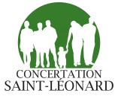
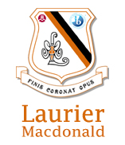
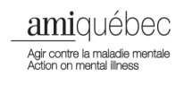
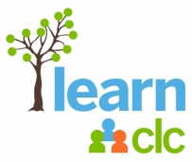
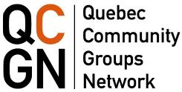
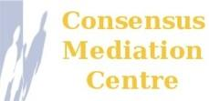
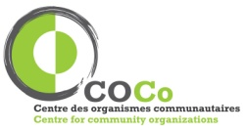
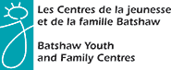
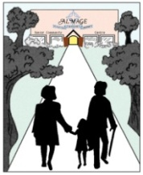
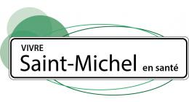
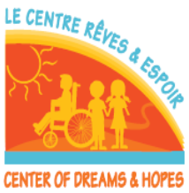
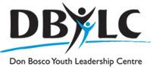
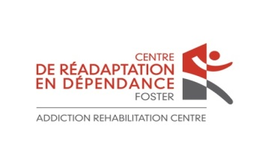
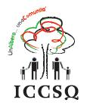

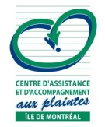

A special thank you to our funders
