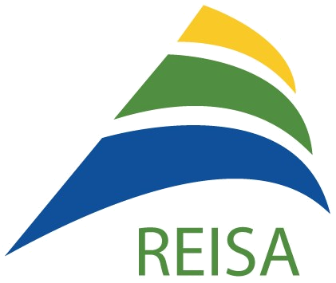
REISA
[one year IN action]

Developing and promoting access to health and social services in English for Montreal's East end!

HIGHLIGHTS

June 2016

Networking and Representation
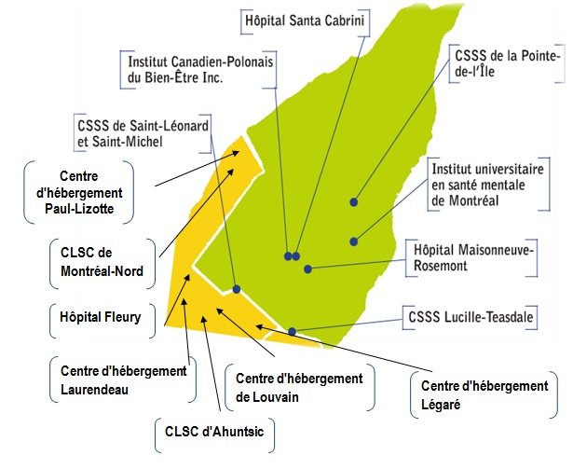

Health Promotion

McGill Retention Project

Adaptation

Knowledge and Best Practices
Upcoming in 2016-2017
- CIUSSS de l'Est-de-l'Île-de-Montréal
- CIUSSS du Nord-de-l'Île-de-Montréal

Community Recognition
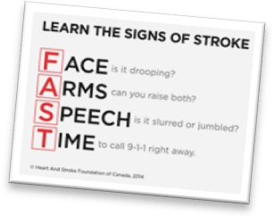
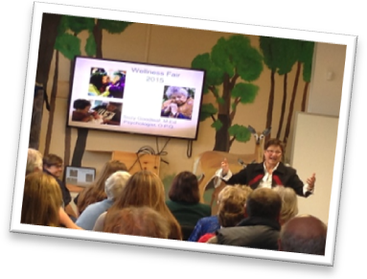
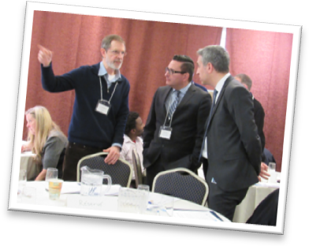
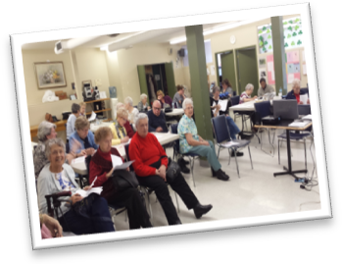

Networking and Representation

Partnership with 2 CIUSSS'
Partnership and assurance of collaboration have been established with newly reformed teams and respondents for access to English language services at the CIUSSS du Nord-de-l'Île-de-Montréal and the CIUSSS de l'Est-de-l'Île-de-Montréal.

Representation on the Boards of the CHSSN and CIUSSS
- Josie Primiani, REISA Board Member was nominated to the Board of the CIUSSS du Nord-de-l'Île-de-Montréal and the Community Health and Social Services Network (CHSSN) Board;
- Ghislaine Prata, Consultant with REISA, was nominated to the Board of Directors of the CIUSSS de l'Est-de-l'Île-de-Montréal and the CIUSSS de Lanaudière.

Community Representation
- Table de concertation des aînés de Montréal-Nord
- Vivre Saint-Michel en Santé
- Collectif Jeunesse
- Concertation Saint-Léonard
- ARC Montérégie Health Fair: Healthy People, Healthy Community!

Health Promotion

Community Health Education Program Videoconferences and DVD Sessions
- Life After Stroke: Resources to help stroke victims, strategies for living after stroke, community rehabilitation and support services
- Better Bowel Health: Treatment of bladder and dysfunctions in men and women of all ages
- Memory Disorders: Tools to better understand and take charge of your brain health
- Stroke−Brain Attack: Understanding and recognizing the signs of a stroke, risk factors and rehabilitation after a stroke
Community Network Forum: The Importance of Health Promotion in the Community
REISA organized the 6th annual Community Network Forum of the Montreal-Laval-South Shore Community Network Table on March 30th, 2016, where initiatives that mobilize communities and empower them to address health promotion and disease prevention were discussed amongst sixty community group members and public health institution representatives.
Community organizations that were in attendance displayed and shared information on their health promotion programs.

Photo from left: Jim Carter (CHSSN), Frédéric Abergel (CIUSSS du Nord-de-l'Île-de-Montréal) and Stéphane Sabourin (CIUSSS du Nord-de-l'Île-de-Montréal)

Photo: Keynote speaker Suzy Goodleaf at ARC Montérégie Health Fair

Photo: CHEP DVD Session at Almage Seniors Centre

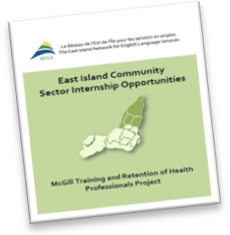

McGill Retention Project

2015-2016 East Island Community Placements
- 3 McGill School of Social Work students
- 9 McGill School of Dietetics and Human Nutrition students
- 1 Dawson College Social Services student
- 1 Vanier College Special Care Counselling student

2016-2017 Planned East Island Community Placements
- 2 McGill School of Occupational Therapy students
- 1 Concordia School of Public Affairs and Policy Studies student


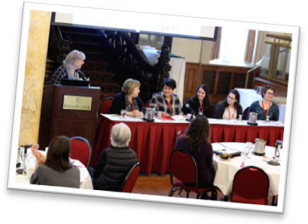
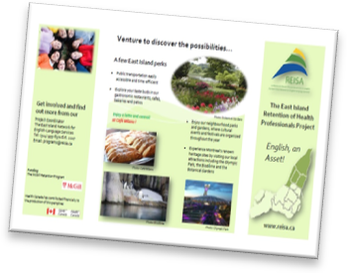
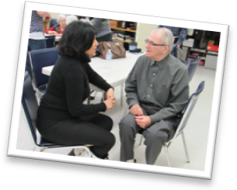
CHSSN Fall 2015 and Spring 2016 Retreat
Retreats provided NPI leadership competency training, promoted team building and resource sharing, to English-speaking health networks across Quebec.

McGill Golden Share: A Meeting of Retention Partners
REISA presented its success story in developing and supporting community placement opportunities in the East end, since 2007, and subsequently retaining these health and social services professionals in the East Island.

Health and Social Services Career Fairs
Production of a pamphlet and booklet promoting East end internship opportunities and careers in-demand for students in health and social services, was disseminated to students at in March 2016 at the McGill Social Work, Physical and Occupational Therapy and Speech, Language and Communication Disorders job promotion fairs.

Adaptation

Liaison Pilot Project: CLSC Mercier-Est−Anjou-REISA-Almage Partnership
Result Highlights: The Liaison initiative for access to health and social services in English to East end seniors led to recognizing the unavailability of informative documentation and care forms in English for the seniors, the facilitation of the trajectory for referral to English services in the network and community and the entry of valid record information in the client's file about language use.

Long-awaited collaboration between Almage Senior Centre and the CLSC: A social worker and a nurse from the CLSC Mercier-Est−Anjou home support services team meeting with the seniors at Almage to demystify the trajectory of a request for services at the CLSC and to present the process of lodging a formal complaint.

Knowledge and Best Practices

Photo: Nurse speaking to Almage Seniors Centre member

Photo: REISA panel discussion

Photo: Lac Delage Retreat

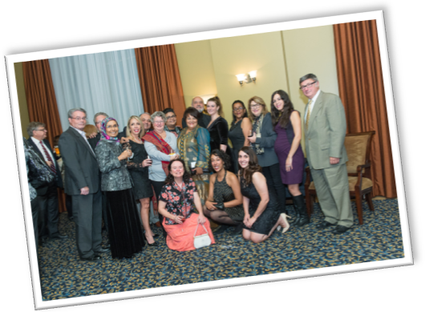
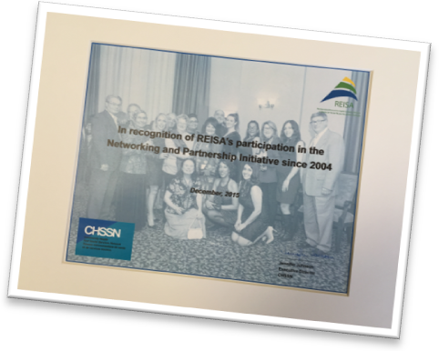
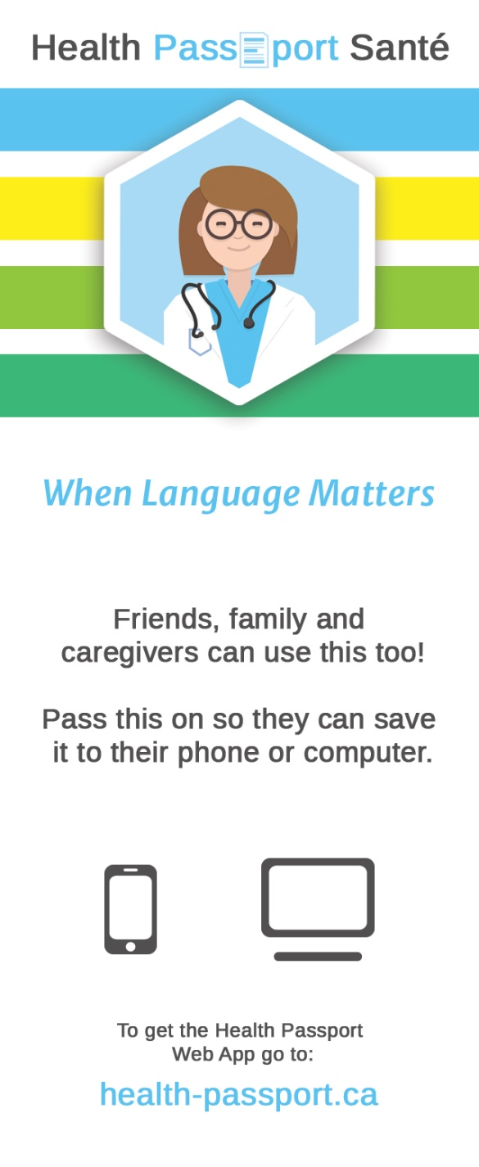
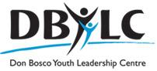


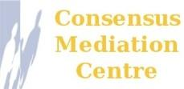
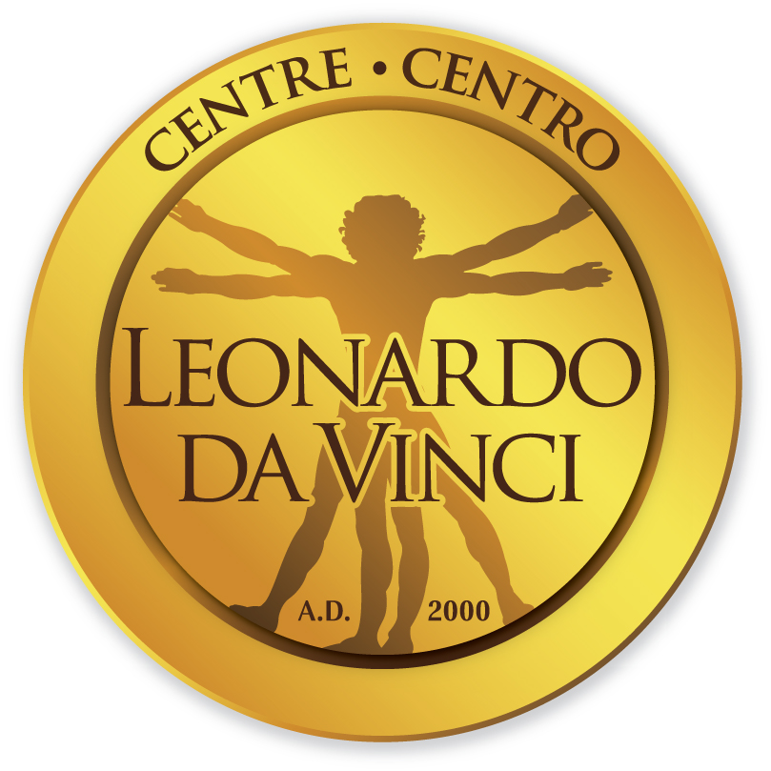
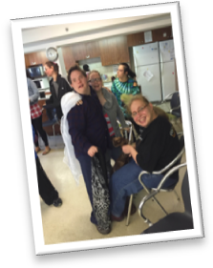
Needs assessment for Special Needs Resources
Parents and caregivers of children and young adults with special needs participated in 2 focus groups at the Centre for Dreams and Hopes (CDH) to discuss the barriers and challenges that they and their families continue to endure in regards to the lack of adequate services and support for English-speaking individuals and families with special needs. A report on the findings will be presented to the 2 CIUSSS'.

Dissemination of Information
Resources produced in 2015-2016:
- Health and Social Services Resource Guide for English-speaking Communities in the East end of Montreal
- Health and Social Services Resource Guide for English-speaking seniors in the East end of Montreal
- Health Passport and Health Passport Web App: For English-speaking persons to communicate with French-speaking health professionals. Web App designed to help individuals keep track of essential health information and puts helpful words and phrases at your fingertips.
- REISA website launch: Collaborating with Commun-IT and COCo to update website and create interactive blog for English-speaking community.

Community Recognition

REISA Acknowledged for 10 Years of Contribution
On December 15th, 2015, the Community Health and Social Services Network (CHSSN) thoughtfully awarded REISA with a certificate of recognition for participation in the Networking and Partnership Initiative, since 2005 REISA has assisted partnership development in three main areas: expansion of local-level services, outreach to new services and community capacity-building.

F. Guemiri, recipient of the Goldbloom Award
On October 8th, 2015, Ms. Fatiha Gatre Guemiri accepted the Quebec Community Groups Network's seventh annual Sheila and Victor Goldbloom Distinguished Community Service Award. Articles congratulating F. Guemiri on her work in encouraging intercultural dialogue were featured in the Red Feather Forum as well as the El Watan newspaper in Algeria.

Upcoming in 2016-2017

Families in Transition - Building Lasting Co-Parenting Relationships
Social network support system and psychosocial services for families experiencing a difficult transition
Girls Club
Building self-esteem, reducing peer pressure and preventing drug addictions for girls at risk from inner-city schools
House of Kings and Queens
Building on inherent strength of individuals through activities and discussions to apply these lessons in real situations to positively impact peers and communities
Photo: Young adults at CDH

Photo: Goldbloom Awards

